

Elettra - Sincrotrone Trieste S.C.p.A.

Laboratorio metrologia e ottica raggi X molli

Experimental Division

S.S. 14 Km 163,5 in Area Science Park - 34149 Basovizza, TRIESTE, ITALY

TEL +39-040-3758632 FAX. +39-040-3758830

|  |  |
| --- | --- |
| Optics under test: | *KAOS* Kirkpatrik-Baez vertical and horizontal mirrors |
| Beamline: | Completare qui (o cambiare voce) |
| Manufacturer: | Carl Zeiss Ag |
| Test period: | June 2016 |

The optical quality of the test mirrors is assessed by means of the following approaches/techniques

|  |  |
| --- | --- |
| **Figure error measurement with Long Tracing Profiler (LTP)** | Measured are performed at 3mm above and below the longitudinal axis (labelled as region 1 and 2 respectively). Number of measures per region: 5. Angular resolution::(xxurad). Temperature 22°C, Humidity <70% |
| **Roughness measurement with ZYGO™ white light interferometer** | Model: L10x Mirau, with 2x magnification ocular. RMS roughness values are reported for Left (LX), Central (CX) and Right (RX) regions in Table 1. The most representative interferometric acquisitions are shown for each sample. |
| **Simulation of the spot intensity at the focal spot** | Simulations are performed using WISE 1.0 engine [cit] |
|  | |

# LTP Measures

Region1 refers to profile measured 3mm upward the longitudinal axis. Region2 refers to profiles measured 3mm downward the longitudinal axis. The RMS is computed over a longitudinal span of 70mm.

# D:\Users\Mic\AppData\Local\Microsoft\Windows\INetCache\Content.Word\KBH_Profiles.pngD:\Users\Mic\AppData\Local\Microsoft\Windows\INetCache\Content.Word\KBH_Rms.png

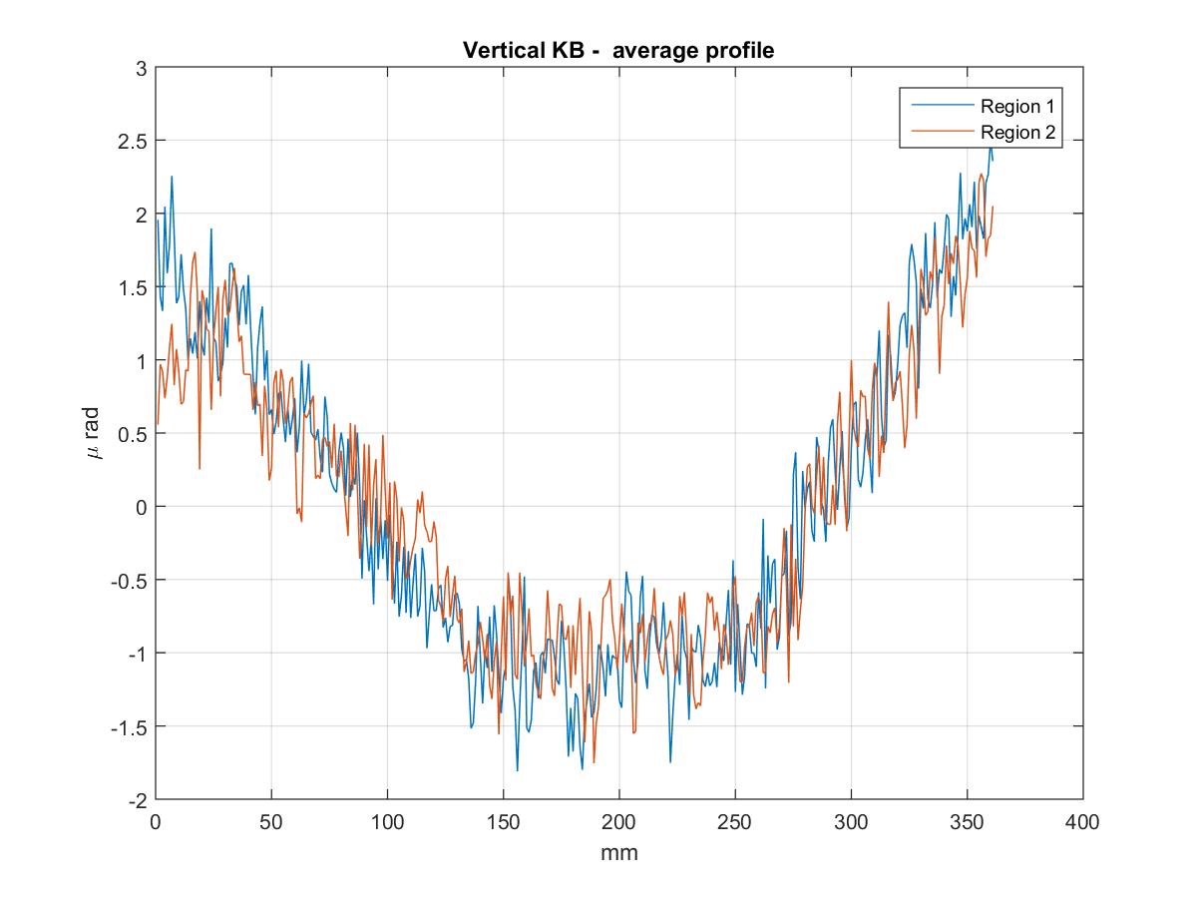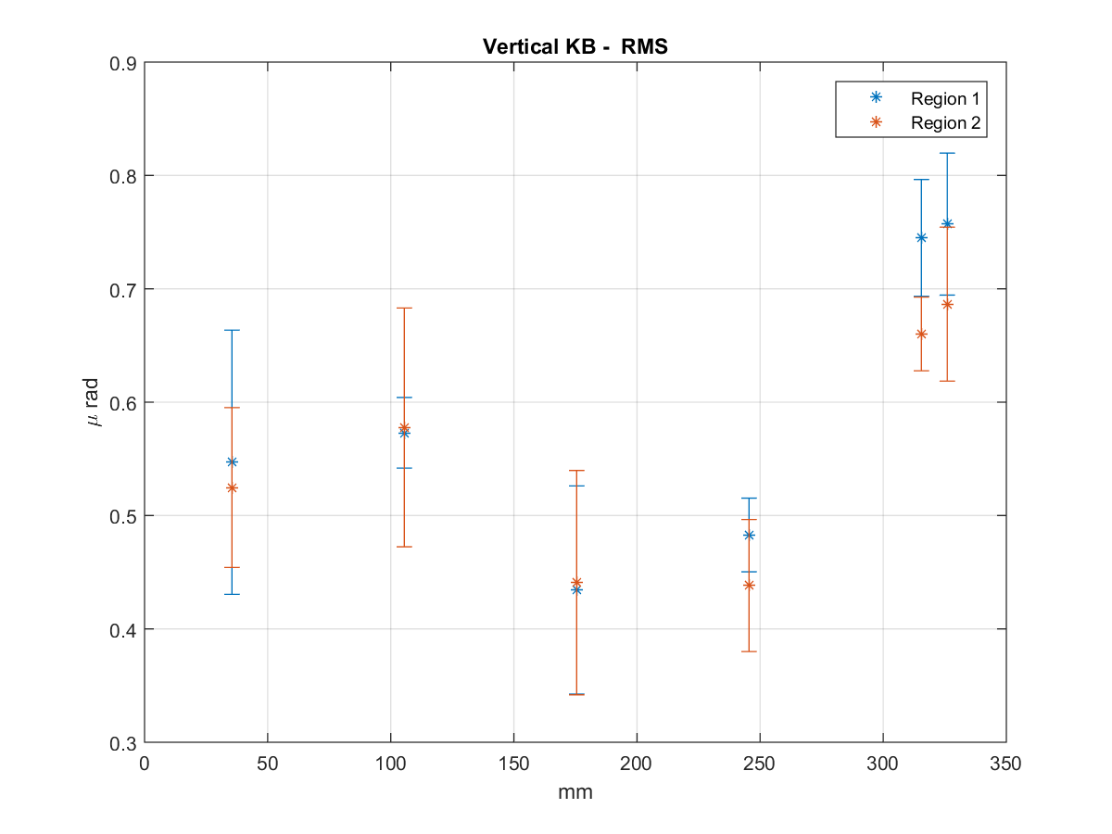

# Roughness measurements

VERTICAL MIRROR (KBV-KAOS)

**CLX:** 15-0106-kbm-v-kaos\_central-left

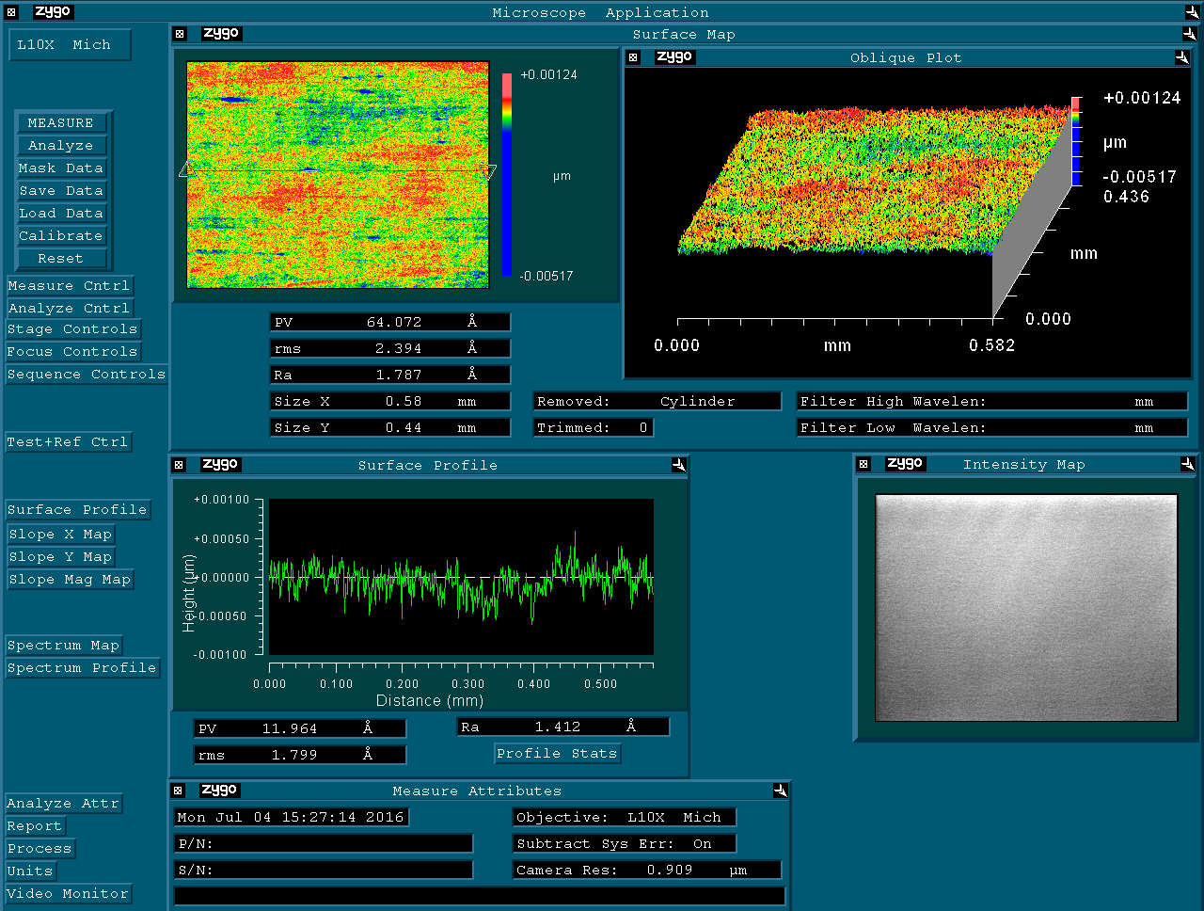

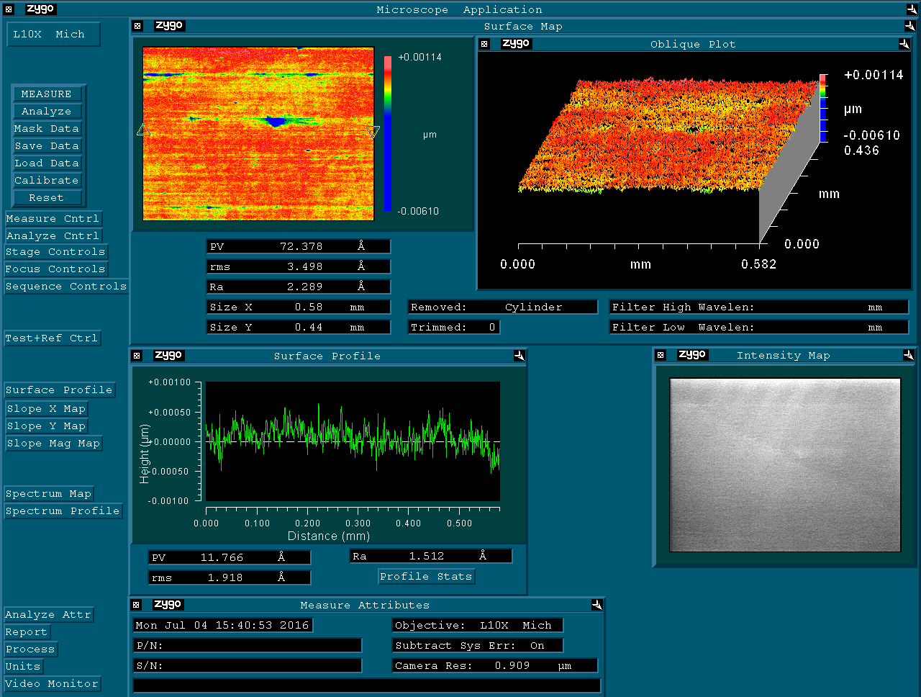**CRX:** 15-0106-kbm-v-kaos\_central-right

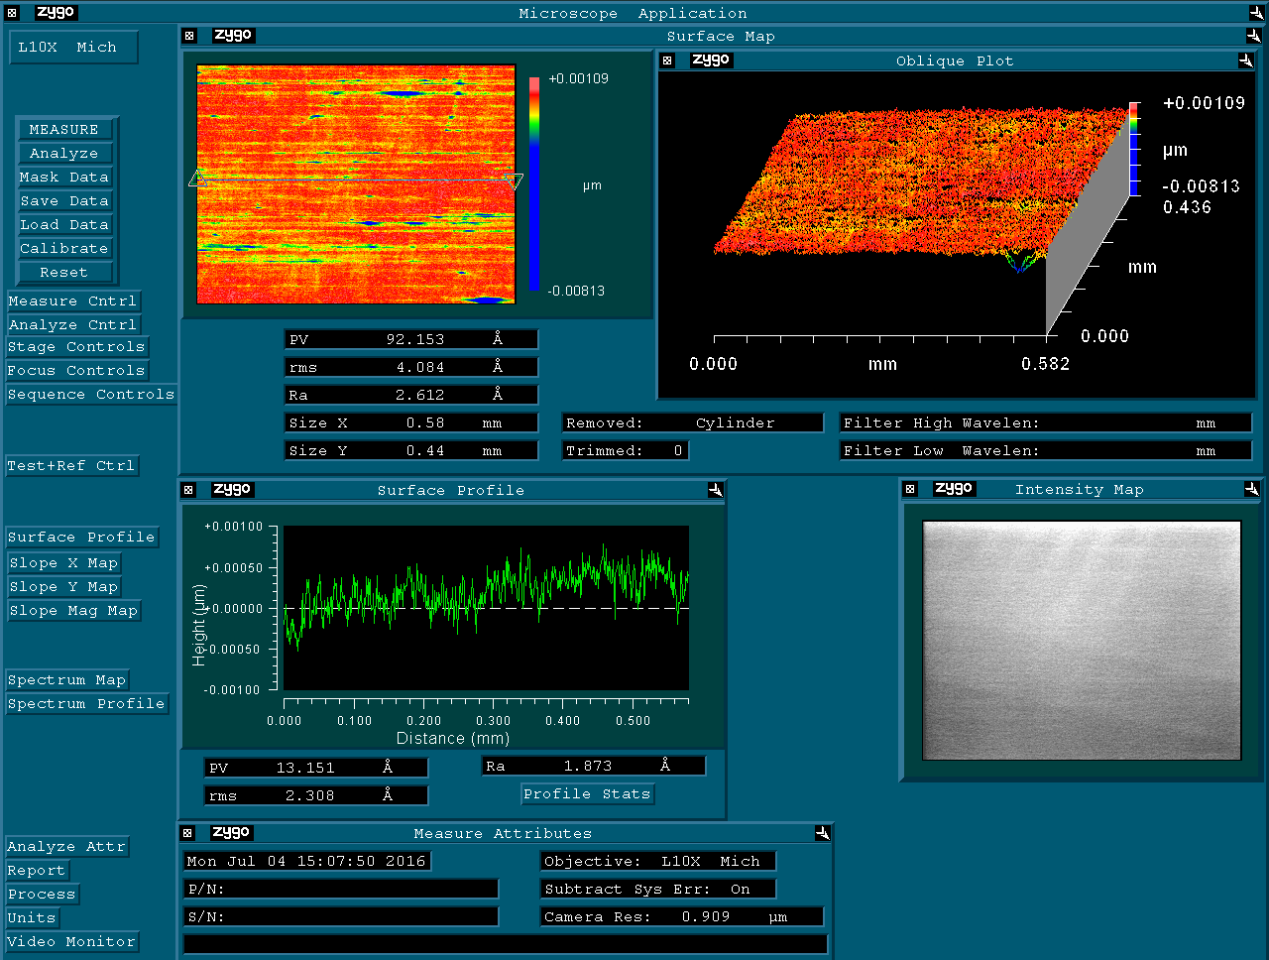**CX:** 15-0106-kbm-v-kaos\_central

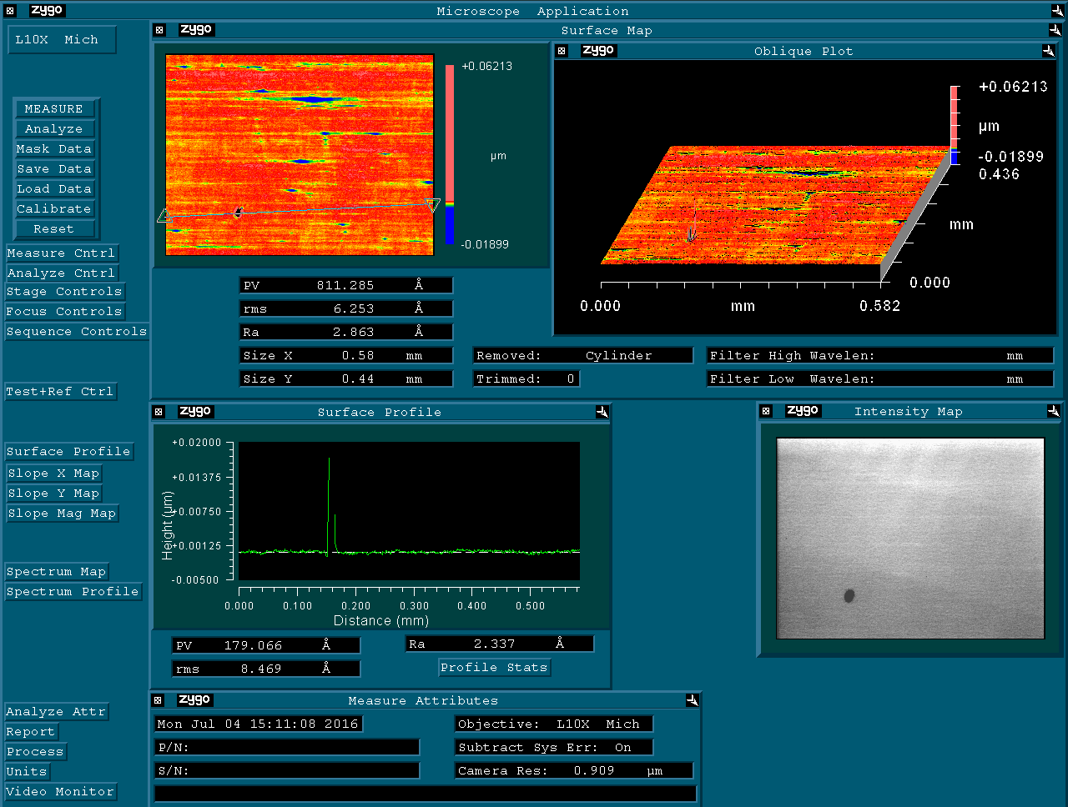**CX (2):** 15-0106-kbm-v-kaos\_central2

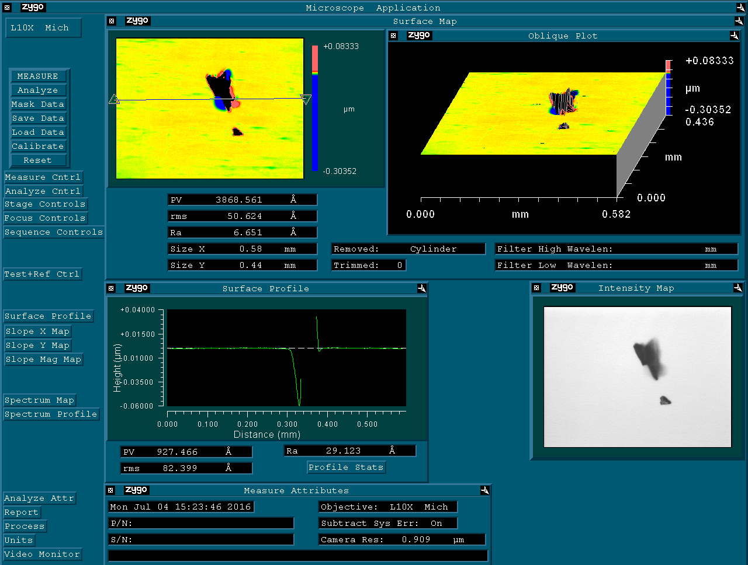

**DX:** 15-0106-kbm-v-kaos\_down

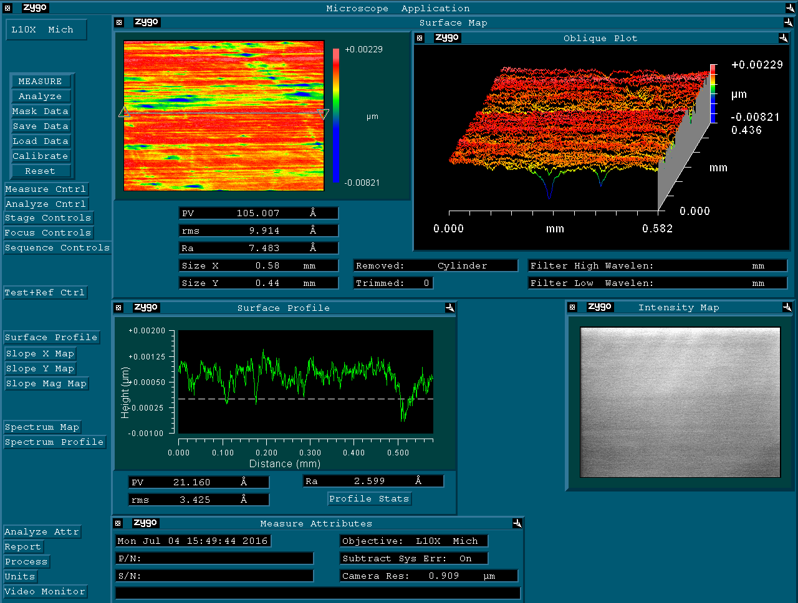**LX:** 15-0106-kbm-v-kaos\_left

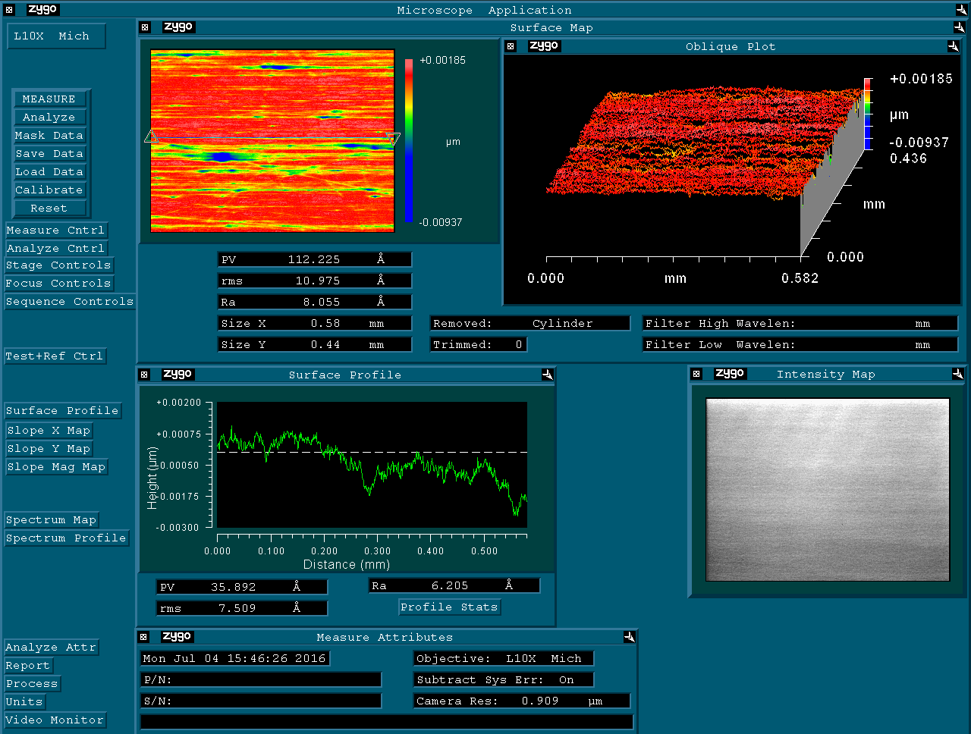**RX:** 15-0106-kbm-v-kaos\_right

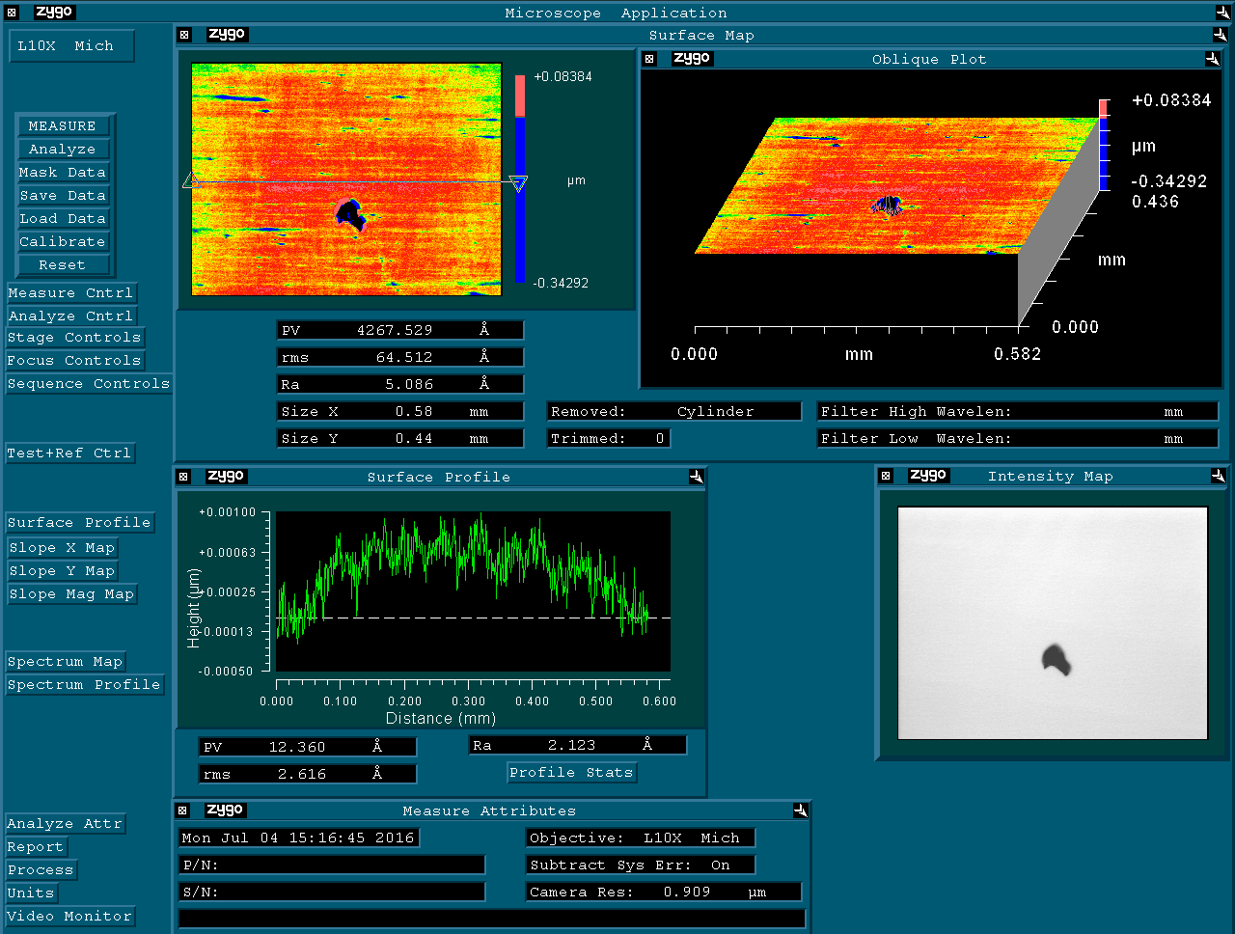**UX:** 15-0106-kbm-v-kaos\_top

HORIZONTAL MIRROR (KBH-KAOS)

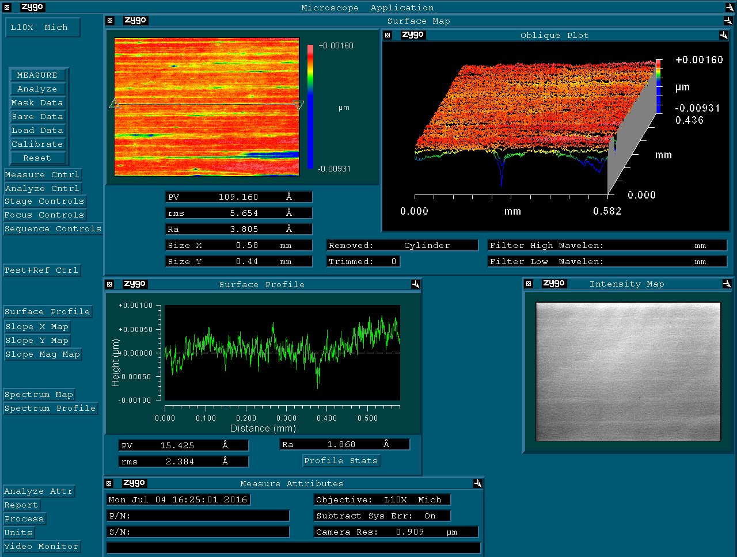

**CLX:** 15-0106-kbm-h-kaos\_central-left

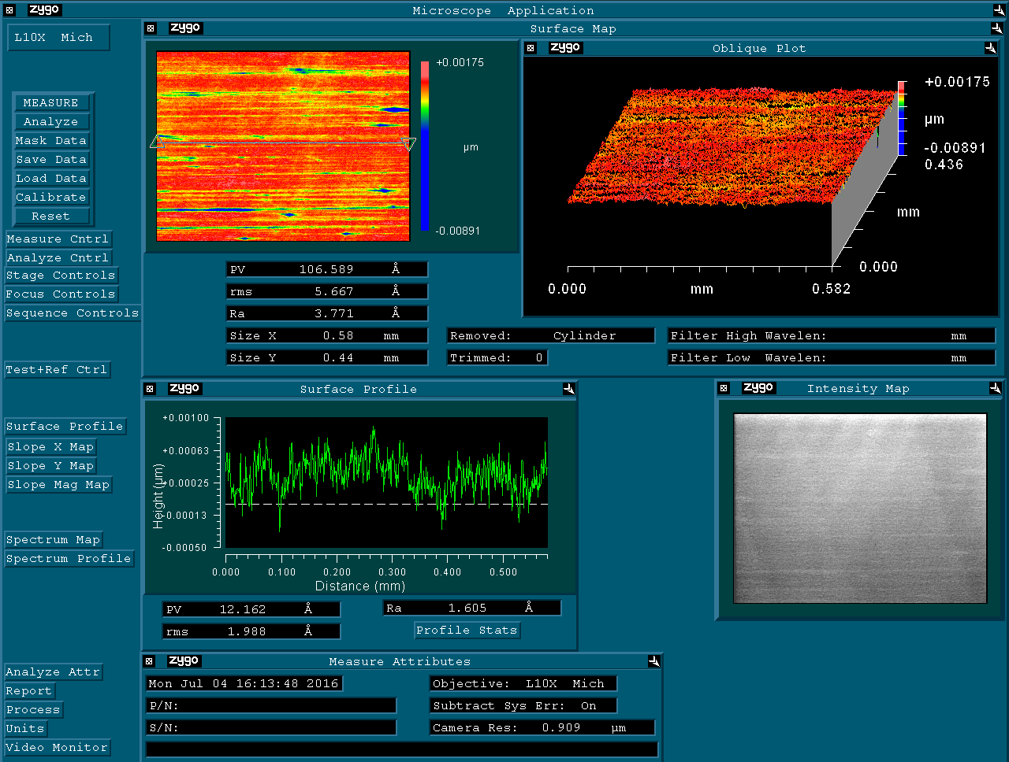**CRX:** 15-0106-kbm-h-kaos\_central-right

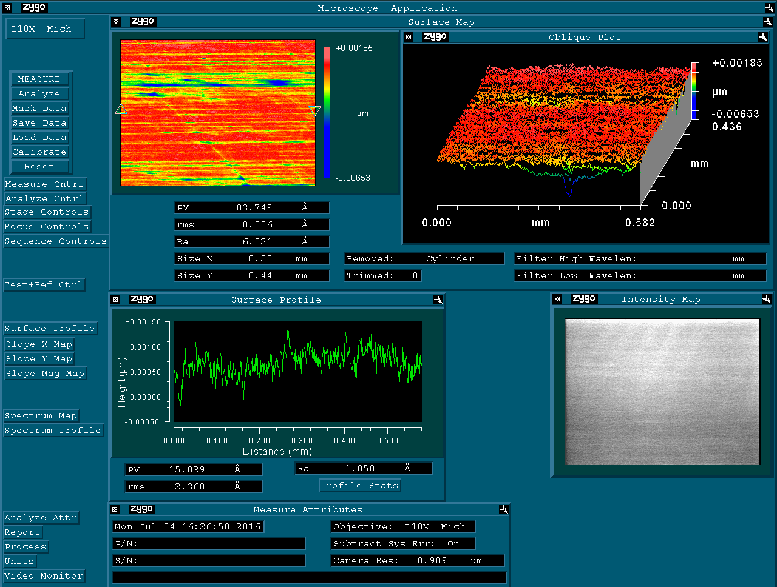**CX:** 15-0106-kbm-h-kaos\_central

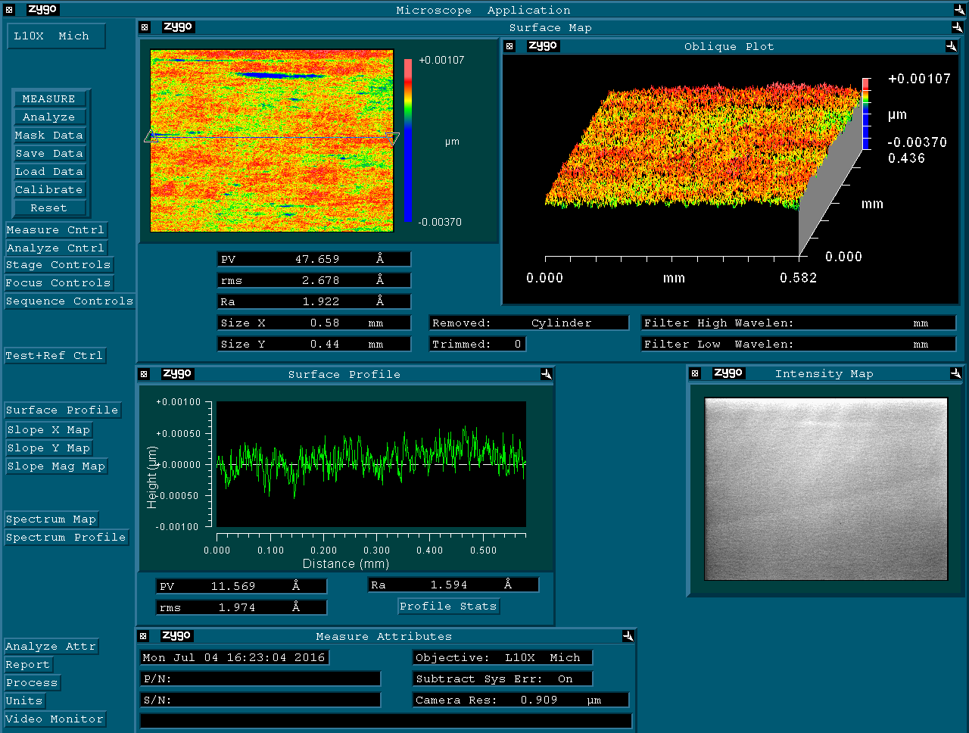**DX:** 15-0106-kbm-h-kaos\_down

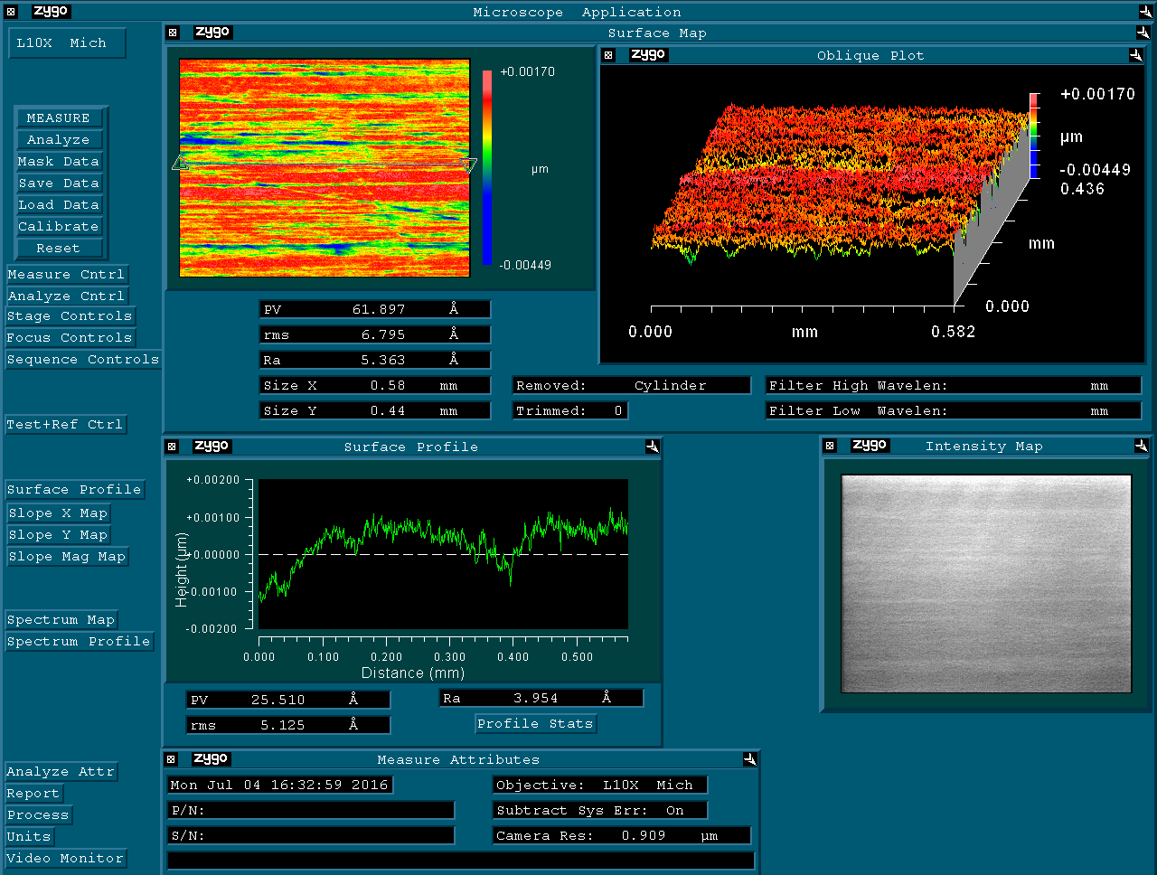**LX:** 15-0106-kbm-h-kaos\_left

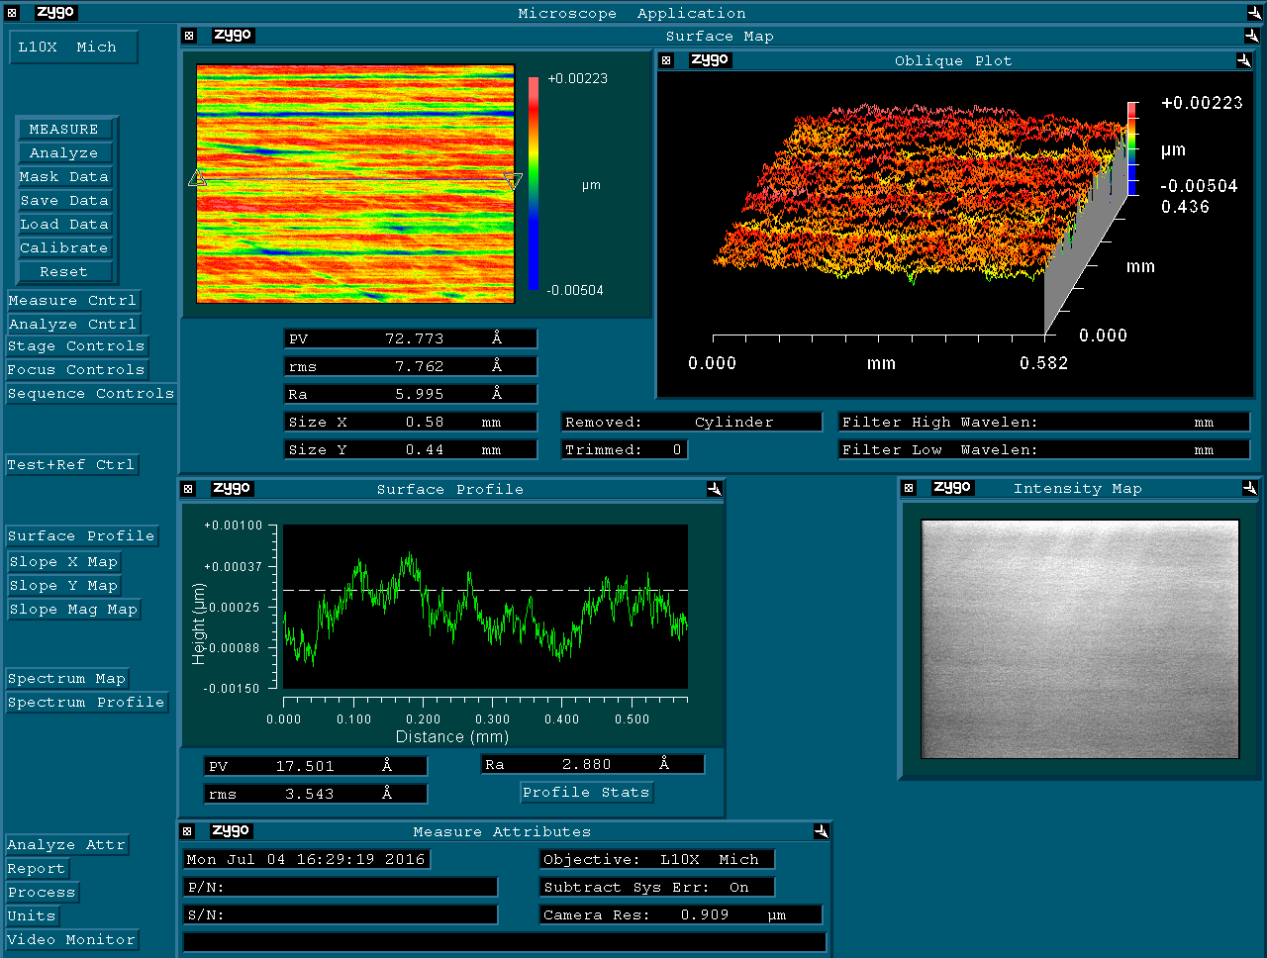**RX:** 15-0106-kbm-h-kaos\_right

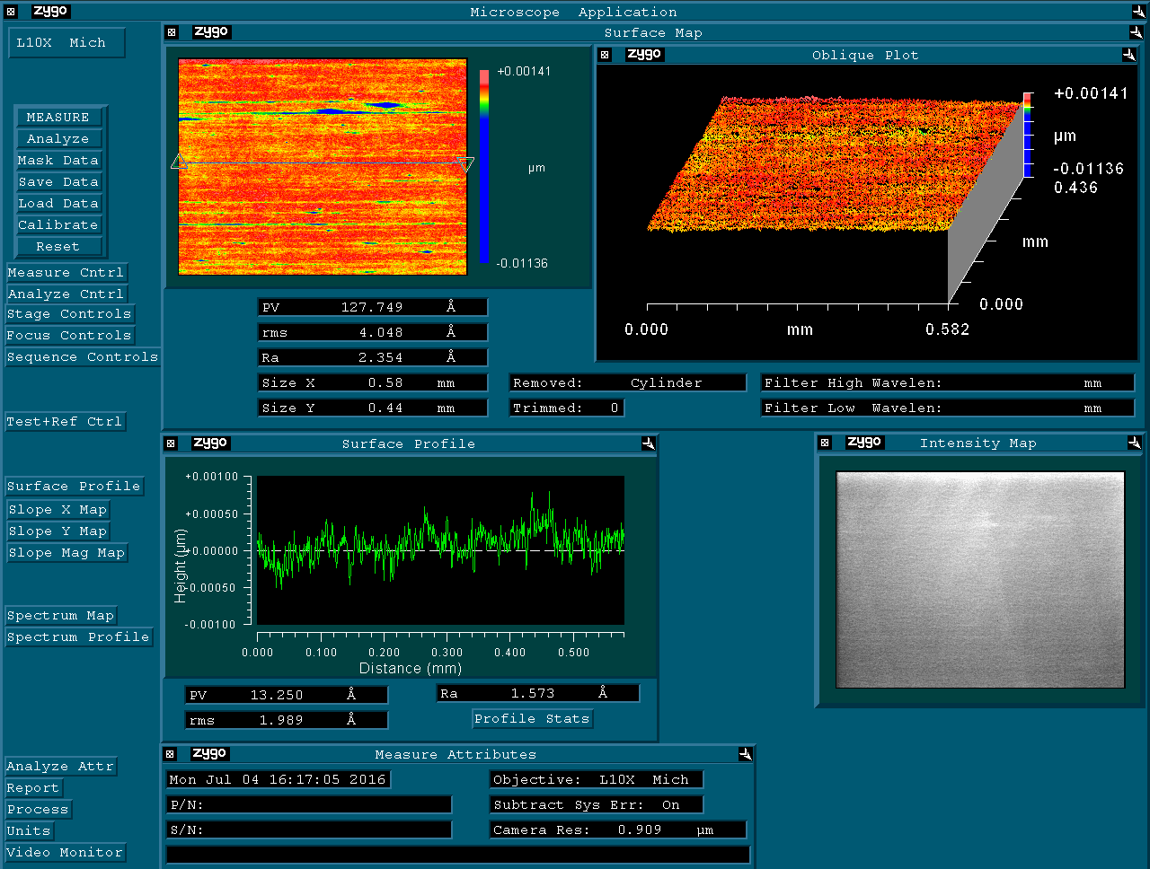**UX:** 15-0106-kbm-h-kaos\_top

# PSF Simulations

Simulations have been performed by means of explicit application of the Huygens-Fresnel integral, as described in [cit]. Figures in this section show the comparison of the intensity of the beam at the focal spot (the Point Spread Function) in the cases of ideal and real focusing. The computation with real focusing includes the effect of roughness as well. In so doing, a conservative evaluation of the roughness PSD (Point Spread Densitu?? ) was given, extracting data from the worst-looking measurement, not exhibiting pathological scratches or damages.

Simulations are performed in the wavelength range 0.1nm-50nm. A point source is used, thus providing a conservative assessment of the focal spot.

No meaningful discrepancy between the ideal and the real case is observed.

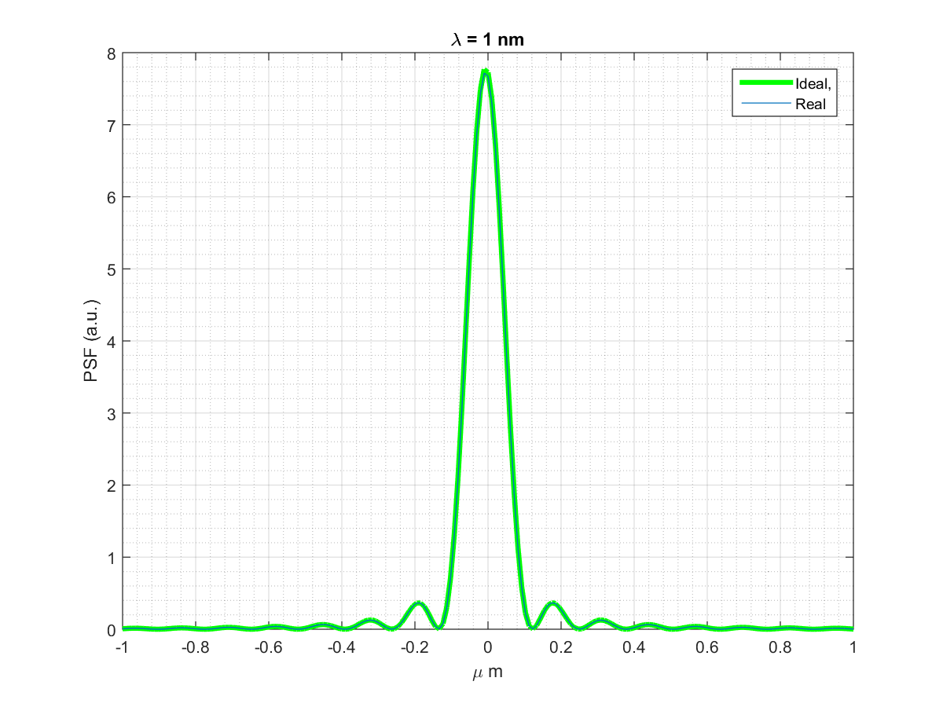

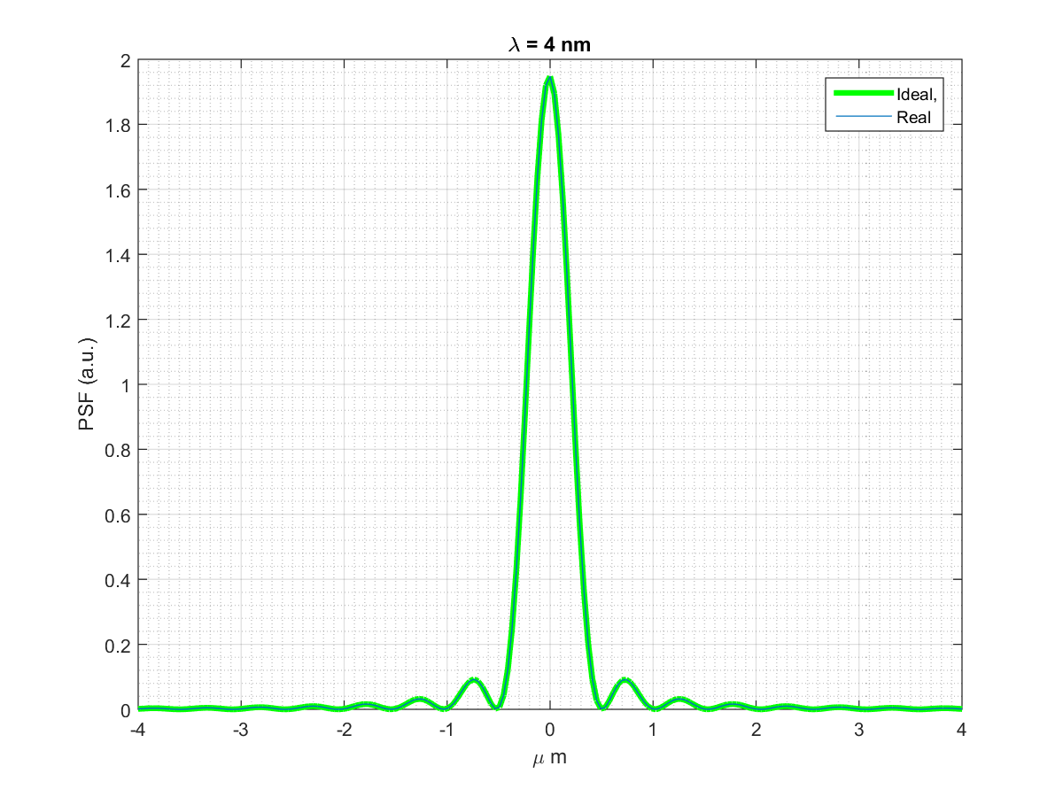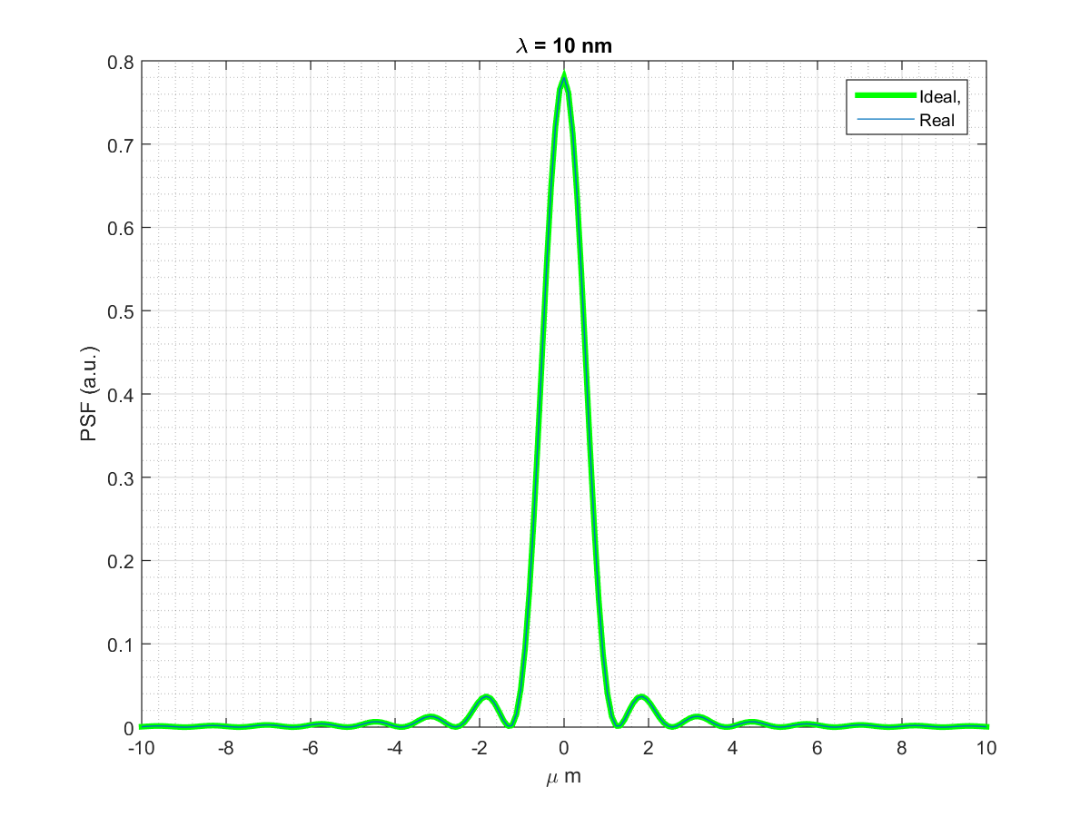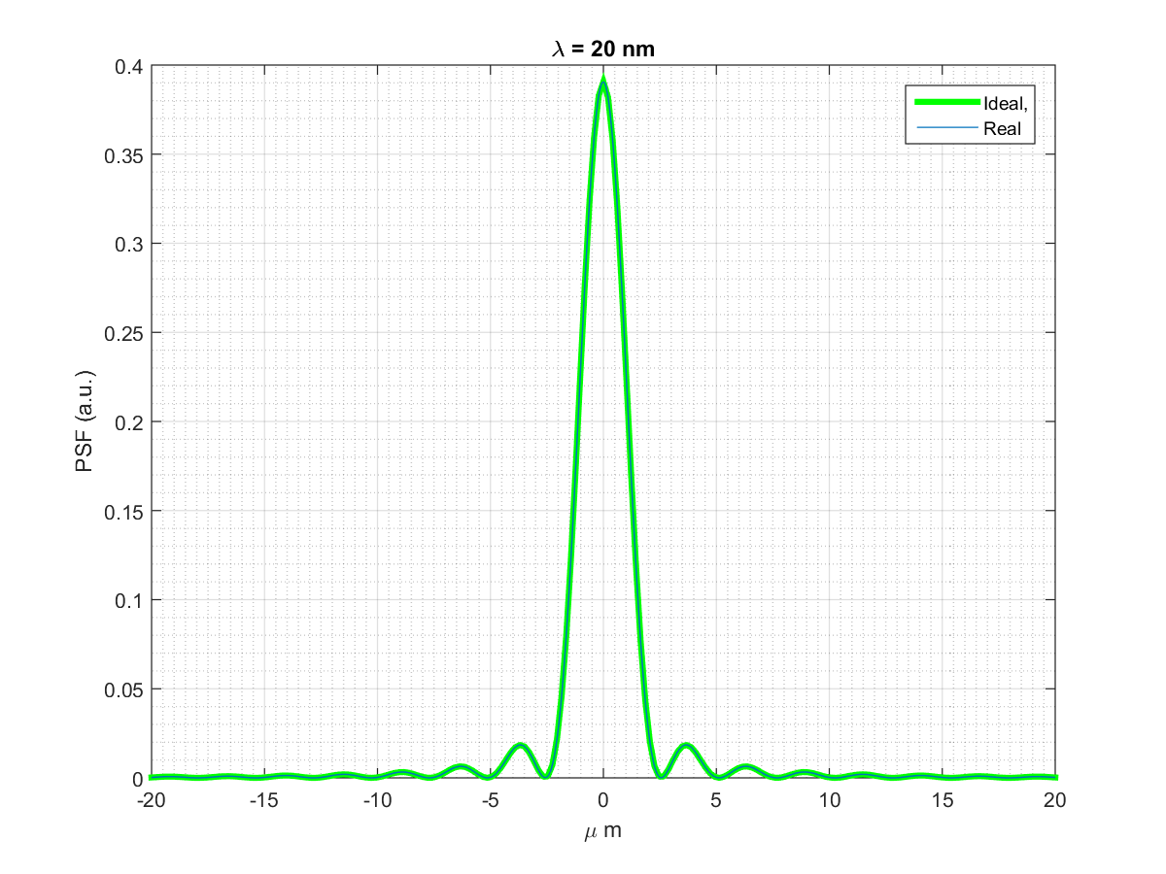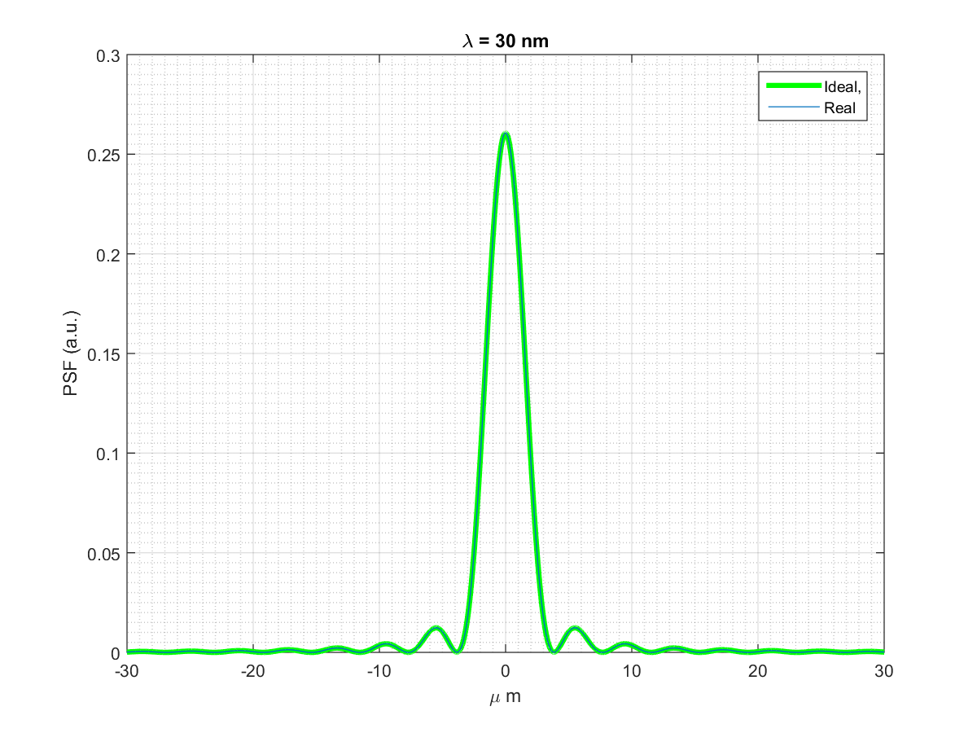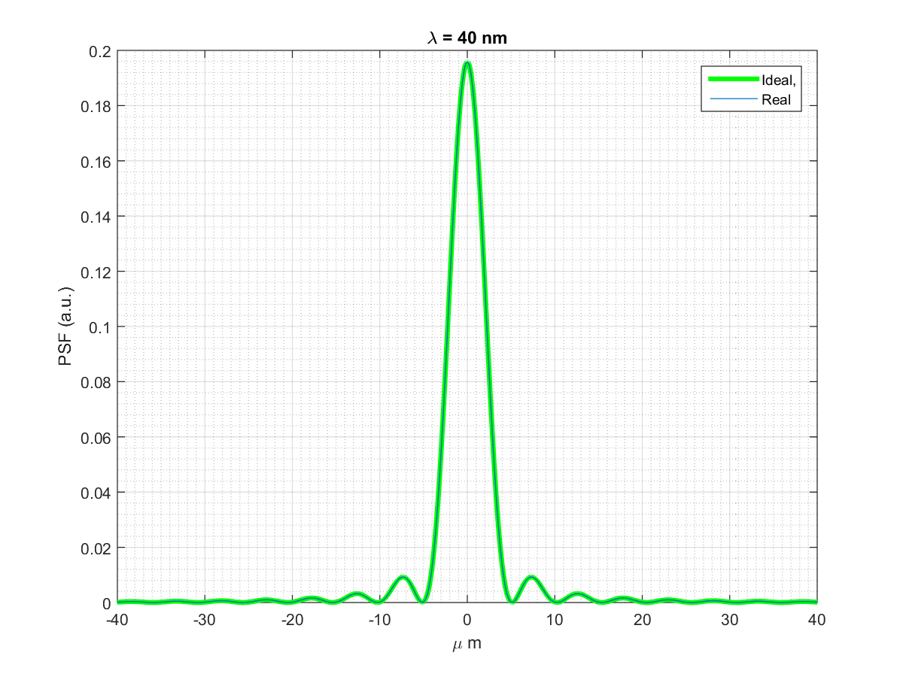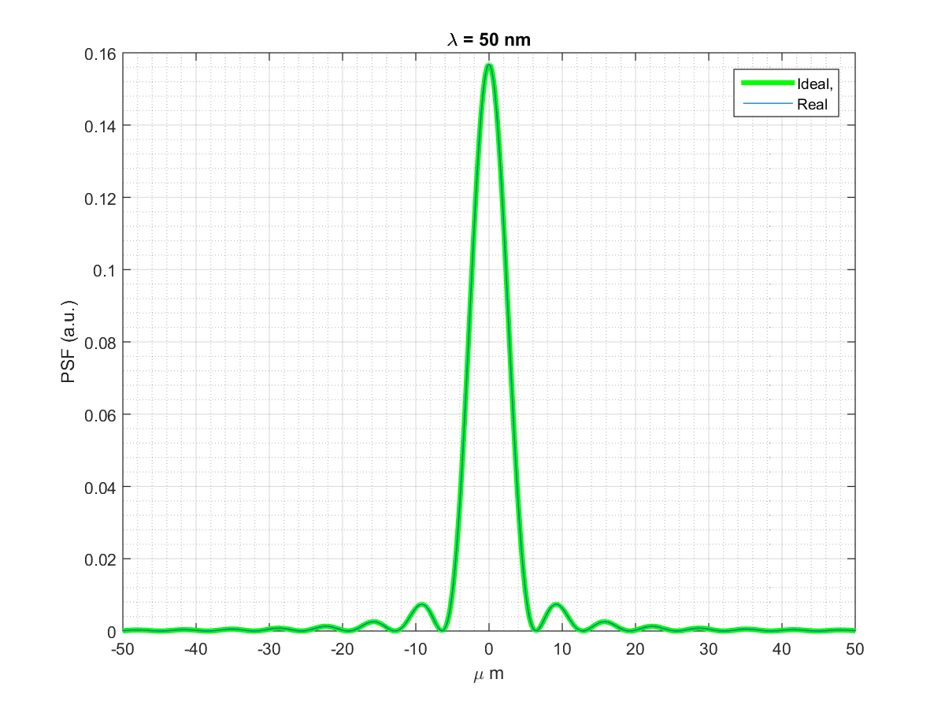

Mi mancano I dati a 0.1 reali e ideali (ho solo uno dei due). Idem per 0.2nm

# Synoptic table of metrology measures

|  |  |  |  |  |  |  |  |
| --- | --- | --- | --- | --- | --- | --- | --- |
|  | Roughness RMS (Ǻ) | | | | | LTP RMS (µrad) | LTP Radius (km) |
| MIRROR ID | LX | CX | RX | UX | DX |  |  |
| KB-H | 6.8 | 8.0 | 7.7 | 4.0 | 2.7 | 0.32-0.52 | 13.0± 1 |
| KB-V | 9.9 | 4.0 | 11.0 | ---- | --- | 0.47-0.77 | 71± 14 |

Table 1 RMS roughness

# Conclusions

The mneasured figure error RMS, computed over over a longitudinal scale of 70mm, comply the requirements of dire quali erano

The measured roughness RMS does not comply the requirements of xxxxxx. In particular, morphological features which can be likened to damages in the coating are observed, especially in the outern region of the vertical kb mirror (UX, DX).

Nonetheless, as neither the figure error nor the roughness appears to affect the PSF, the test optics shall be considered as suitable for the KAOS system,

ù

12 July 2016

Simone Gerusina Metrology technician

Michele Manfredda Scientific advisor

Lorenzo Raimondi Head of the Optical Metrology Laboratory

Elettra-Sincrotrone Trieste